Ethical Concerns for End-of-Life Care for the Uninsured Populations in the USA.
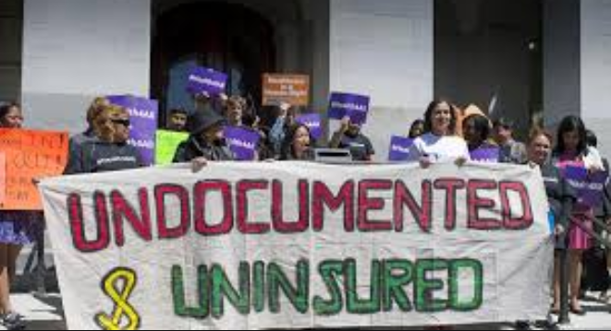
Introduction.
- America has a Large Number of Uninsured Populations.
- According to Jaramillo & Hui, (2016), there are about 11 million uninsured immigrants in the context of the United States, and Latino is the leading population.
- The undocumented Americans have been poorly represented and covered in the healthcare sector. Jaramillo & Hui, (2016) argues that the people of color are at high risks of remaining uninsured and hence they are unable to access preventive care as well as services for major health conditions and chronic illnesses such as cancer.
- Undocumented Immigrants are not eligible for the Medicaid program.
- Latinos and blacks make 19% and 11% of the uninsured population (Jaramillo & Hui, 2016).
- Jaramillo & Hui, (2016), asserts that undocumented immigrants ailing with cancer are likely to get inadequate care services since they are not only challenged by the immigration system but also the unfavorable health care system.
- It has been agreed that a low level of education, lack of common language, poverty, and reduced social support are the leading causes of the poor end-of-life care for the undocumented populations.
Learning Objectives.
- To provide a demographic data of the uninsured population.
- Define ethical issues attached to the end-of-life care for the uninsured populations.
- Provide teaching information from health care professionals for addressing this cohort.
- Outline interventions for this cohort.

Demographic Data of the Uninsured Population.

- Increased access to health coverage stands a chance to change a person’s healthy life.
- According to Jaramillo & Hui, (2016), about 27 million nonelderly in the context of America have remained without health coverage.
- The implementation of the Affordable Care Act is said to have had larger coverage against the people of color through the expansion of Medicaid programs.
- According to statistics, about 85% of the uninsured are nonelderly adults (Fazel-Zarandi, Feinstein, & Kaplan, 2018).
- About 25% of the uninsured populations accounts from the undocumented immigrants who are ineligible for enjoying federally funded health coverage.
- The uninsured population varies from state to state.
- Majority of the uninsured are poor, contributing to the 138% lower than the poverty line. About 47% of this population are Latino Americans (Fazel-Zarandi et al., 2018).
- Students have defined that many of the undocumented immigrants are unable to afford the coverage even after having qualified for health subsidies.
- Healthcare system tends to be biased in terms of provision of healthcare coverage.
Ethical Issues Attached to the End of Life Care for the Uninsured Population.
- Undocumented patients are faced with lingering encounters and unique ethical concerns during the end of care.
- They are often vulnerable to unfair treatment, more so those ailing with terminal illnesses.
- Bioethicists must fight for favorable practices concerning the end-of-life choices applicable to the undocumented patients.
- It should be confirmed that health care providers are not erroneously examining the relative importance as well as burdens of the medical treatments when attending an undocumented patient (Warren, 2017).
- Ethicists need to discuss tangible facts with administrators who often oversee charity care in conjunction with medically sophisticated discharge rules and procedures as well which often undermine the undocumented patients.
- Many undocumented immigrants have often avoided care due to the fear of deportation, a practice which is not suitable for acute care environment.
- Undocumented patients have been served with ethically distinguishable care.
- Undocumented populations have often been discriminated in organ transplant services, and this implies the violation of the bioethical principle of justice.
Teaching Information from Health Care Professionals for Addressing Ethical Concerns with the Uninsured Population.
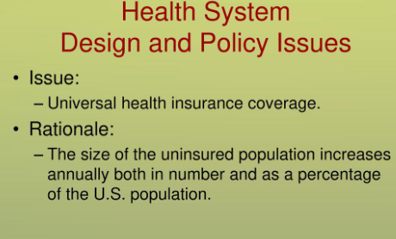
- The health care professionals need to understand that;
- Undocumented or uninsured patients have no difference with the covered patients and hence all they should be subjected to safety net programs to address the terminal illnesses.
- Health care professionals should be reflective of the Ethical Codes for Nursing while focusing on the just and fair treatments for all patients regardless of color or ethnicity.
- Undocumented patients are not substantial users of healthcare services. Majority of the undocumented patients fear medical treatment for chronic illnesses since they associate health care providers with Homeland Security. The provider should get armed to evaluate this perception and cultivate acute care environment.
- Medical providers must comprehend that failure to adhere to the medical appointments may be as a result of poverty and lack of health coverage.
- End-of-life care poses challenges to both ends of the ethical care spectrum.
- Health care professionals should adhere to the same good practices which are effective in the facilitation of quality end-of-life decisions for the uninsured patients.
- Hospitals are required to make outpatient care as well as housing resources available for the undocumented patients.
Interventions for Ethical Issues at the End-Of-Life Care with the Uninsured Population.

- Expansion of Medicaid programs to improve access to health care for the undocumented population within their state of residence.
- Documentation of the undocumented populations.
- States, as well as counties, should subsidize cancer treatment programs eligible for undocumented patients (Cervantes et al., 2017).
- Ensure ethically indistinguishable care for all patients regardless of color and ethnicity.
- Make a clear distinction amid the homeland security and the health care personnel to alleviate reduced access to health care service due to fear of deportation.
- Facilitate effective organ transplant initiatives for undocumented patients (Fox, 2017).
- Disseminate health education to all undocumented immigrants on the importance of seeking for medical treatment for both mild and terminal illnesses.
- Ensure common language amid immigrants and health care providers.
- In-service training for health care professionals to ensure updated adherence to the needs of the terminally ill undocumented patients.
- Financial support to health organization to create an acute care environment for the undocumented patients.
The Role of the Healthcare Provider.
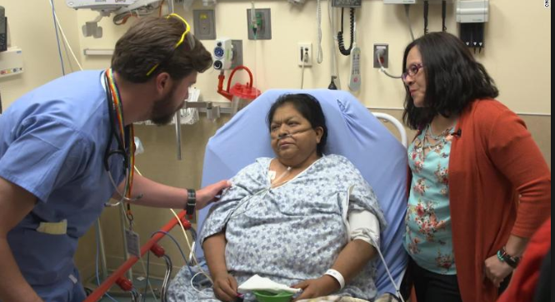
- Advocate for the expansion of Medicaid programs eligible for undocumented patients.
- Participation in charity programs for caring to the terminally ill undocumented patients.
- Provision of health education to the undocumented immigrants.
- Oversee for just and fair treatment of all uninsured patients in the context of the US (Cervantes et al., 2017).
- Carry out research and recommend to the government in need for health coverage for the undocumented populations living in the American land.
- Interpret to the patients wherever language is a barrier.
- Emphasize in the quality of end of life choices for the terminally ill patients.
- Advocate for the permission for the undocumented patients to enjoy organ transplant services.
- Offer guidance to the undocumented patients ensuring the end-of-life illnesses.

References.
Cervantes, L., Fischer, S., Berlinger, N., Zabalaga, M., Camacho, C., Linas, S., & Ortega, D. (2017). The illness experience of undocumented immigrants with end-stage renal disease. JAMA internal medicine, 177(4), 529-535.
Fazel-Zarandi, M. M., Feinstein, J. S., & Kaplan, E. H. (2018). The number of undocumented immigrants in the United States: Estimates based on demographic modeling with data from 1990 to 2016. PloS one, 13(9), e0201193.
Fox, R. C. (2017). Spare parts: Organ replacement in American society. Routledge.
Jaramillo, S., & Hui, D. (2016). End-of-life care for undocumented immigrants with advanced cancer: documenting the undocumented. Journal of pain and symptom management, 51(4), 784-788.
Warren, R. (2017). Zero undocumented population growth is here to stay and immigration reform would preserve and extend these gains. J. on Migration & Hum. Sec., 5, 491.

